**MEF UNIVERSITY**

**CUSTOMER CLUSTERING WITH MACHINE LEARNING**

**Capstone Project**

**Ömer Faruk Kara**

**ISTANBUL, 2020**

**MEF UNIVERSITY**

**CUSTOMER CLUSTERING WITH MACHINE LEARNING**

**Capstone Project**

**Ömer Faruk Kara**

**Advisor:**

**ISTANBUL, 2020**

**MEF UNIVERSITY**

Name of the project: Customer Clustering with Machine Learning

Name/Last Name of the Student: Ömer Faruk Kara

Date of Thesis Defense: 13/09/2020

14/09/2020

14/09/2020

We hereby state that we have held the graduation examination of __________ and agree that the student has satisfied all requirements.

**THE EXAMINATION COMMITTEE**

Committee Member Signature



# Academic Honesty Pledge

I promise not to collaborate with anyone, not to seek or accept any outside help, and not to give any help to others.

I understand that all resources in print or on the web must be explicitly cited.

In keeping with MEF University’s ideals, I pledge that this work is my own and that I have neither given nor received inappropriate assistance in preparing it.

Name Date Signature

Ömer Faruk Kara 14/09/2020

# EXECUTIVE SUMMARY

CUSTOMER CLUSTERING WITH MACHINE LEARNING

Ömer Faruk Kara

Advisor:

SEPTEMBER 2020

If you are analyzing a company that sells in very different product ranges, you are likely to encounter different types of customers. If you can classify these customers correctly. It can set standard actions while serving them. In this way, it can gain speed and can be improved as standard actions are determined.

**Key Words**: Machine Learning, KMeans Algorithm, Principal Component Analysis (PCA)

# ÖZET

MARKET ALIŞVERİŞÇİ PAZARLAMASI UYGULAMALARI:

SEPET ANALİZİ VE ÖNERİCİ SİSTEM

Ömer Faruk Kara

Tez Danışmanı:

EYLÜL 2020, 17 sayfa

Eğer çok farklı ürün gamlarında satış yapan bir şirketi analiz ediyorsanız, birbirinden farklı tipte müşteriler ile karşılaşmanız olasıdır. Eğer bu müşterileri doğru sınıflandırabilirseniz. Onlara hizmet verirken standart aksiyonlar belirleyebilir. Bu sayede hız kazanabilir ve standart aksiyonlar belirlendiğinden geliştirilebilir.

**Anahtar Kelimeler**: Makina Öğrenmesi, kmeans algoritmasi, PCA

TABLE OF CONTENTS

Academic Honesty Pledge vi

EXECUTIVE SUMMARY vii

ÖZET viii

1. INTRODUCTION 1

2. LITERATURE REVIEW ON CLUSTERING 2

What is Kmeans Algorithm? 2

What is Silhouette Analysis? 3

What is Principal Component Analysis (PCA)? 4

3. THE PROJECT 5

Step 0: Company Characteristics and Main Goal 5

Step 1: Preparing the data 6

Step 2: Setting Enviroment 7

Step 3: Python Code 8

Step 4: Run the code 11

Step 5: Results 12

APPENDIX 16

REFERENCES 17

# 

.

# INTRODUCTION

In today's competitive world, understanding customer behavior and categorizing customers based on their demographics and purchasing behavior is essential.

It allows marketers to better adapt their marketing efforts to various audience subsets in terms of promotion, marketing and product development strategies.

We call Customer Segmentation when a market is divided into separate customer groups that share similar characteristics. Using Customer Segmentation to identify unsatisfied customer needs can be a powerful tool. Companies using this data in the world and in our country can gain an advantage in the competition by developing uniquely attractive products and services.

These homogeneous groups formed in Cluster Analysis (using a mathematical model to discover similar customer groups based on finding the smallest variations among customers within each group), one of the methods used for customer segmentation, are known as "customer archetypes" or "personas".

The goal of Cluster Analysis is to accurately segment customers to achieve more effective customer marketing through customization. The frequently used method of cluster analysis is a mathematical algorithm known as k-mean cluster analysis and sometimes called scientific segmentation. The resulting clusters help better customer modeling and predictive analytics, and are also used to target customers with personalized offers and incentives based on their wants, needs and preferences.

The data itself is not based on any rules or sub-limits. Customer samples naturally emerge from the customers.

**Ref: [1] [2] [3]**

# LITERATURE REVIEW ON CLUSTERING

## What is Kmeans Algorithm?

It is used to grouping the elements in dataset. Each element should be in only one group. It tries to make the center of the clusters far from each other. Cluster’s centroid is arithmetic mean of all the data points that belong to that cluster.

You have to define, how many cluster you want, to use KMeans algorithm. It begins with a random centroid and then tries to find best center for each cluster. And assign data points to closest centroid.

The algorithm starts with the process of splitting n elements into k sets. After the K centroid is determined, the distances of the elements to the k centroids are calculated and the closest points to the k centroid form a cluster. Cluster elements are averaged and centroids are determined again. If the centroid has changed, it is found which centroid the points belong to according to their distance to the center, and this process continues until the centroid becomes stable.

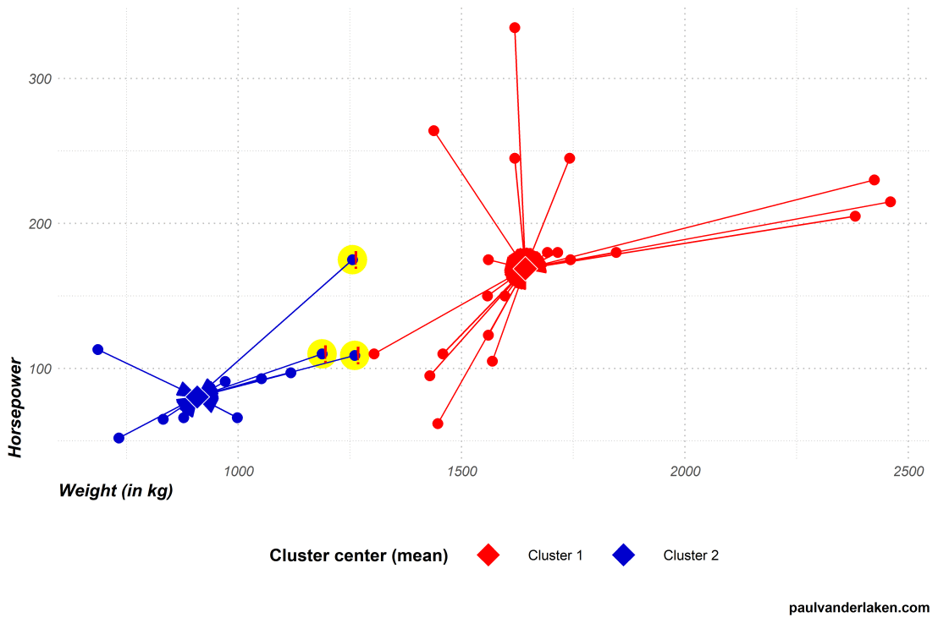

**Ref: [4]**

## What is Silhouette Analysis?

Silhouette analysis can be used to examine the separation distance between emerging clusters. The silhouette plot shows a measure of how close each point in a cluster is to points in neighboring clusters and thus provides a way to visually evaluate parameters such as cluster number.

With this value, we find out how different sets are from each other. We confirm that the closer the value between +1 and -1 is to +1, the better the number of clusters. This value is found by the equation created between the average distance between the clusters and between them.

The Silhouette Coefficient is calculated using the mean intra-cluster distance (a) and the mean nearest-cluster distance (b) for each sample. The Silhouette Coefficient for a sample is (b - a) / max(a, b). To clarify, b is the distance between a sample and the nearest cluster that the sample is not a part of. Note that Silhouette Coefficient is only defined if number of labels is 2 <= n_labels <= n_samples - 1.

## What is Principal Component Analysis (PCA)?

Principal Component Analysis is a useful statistical technique used in the fields of recognition, classification and image compression. It is a technique whose main purpose is to keep the data set with the highest variance in high dimensional data, but to provide dimension reduction while doing this. By finding general features in multi-dimensional data, it enables to reduce the number of dimensions and compress the data. Certain features will be lost with size reduction; but the intention is that these lost traits contain little information about the population. This method combines highly correlated variables to create a smaller set of artificial variables called “principal components” that make up the most variation in the data.

PCA is a very effective method for revealing the necessary information in the data. The basic logic behind PCA is to show a multidimensional data with fewer variables by capturing the basic features in the data. 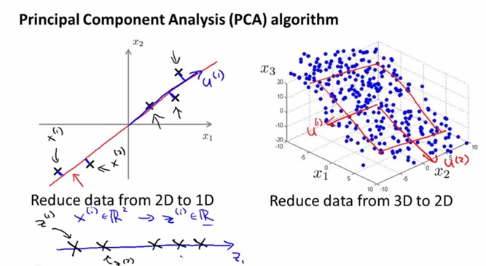

Image Source: Machine Learning Lectures by Prof. Andrew NG at Stanford University

**Ref: [6]**

# THE PROJECT

## Step 0: Company Characteristics and Main Goal

Our example company is an international company providing hardware and fitting systems and electronic access control systems. It’s customers from the furniture industry, dealers, joiners and cabinet makers, as well as architects, planners and builders.

Our purpose is grouping this companies customers based on their purchases.

But we are not doing a RFM analysis so we don’t want to compare or group them by their purchase size. We want to analyze if there is correlation in their purchased product groups ratio over total purchase.

## Step 1: Preparing the data

**Data Set**

Company’s last 12 months invoice data. Columns user are;

CUSTOMER_NUMBER

PRODUCT_GROUP

TOTAL_INVOCES_AMOUNT

INVOICED_DATE used for filtering last 12 months.

**Data Preparation**

After exporting data from our ERP system, I’m using Qlikview to Pivot data by Customer X Product Group with SUM of Invoiced Amount.

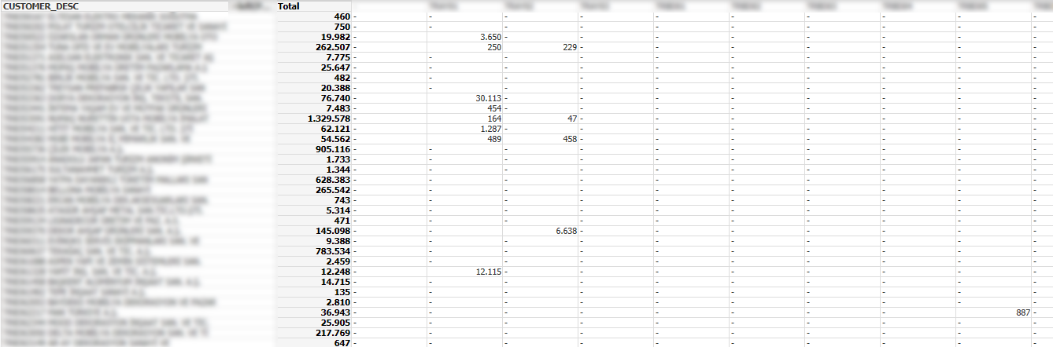

Figure : Customers Purchases by Product Group

In this analysis we are not interested in Customers purchase capacity so we will use percentage of each product group.

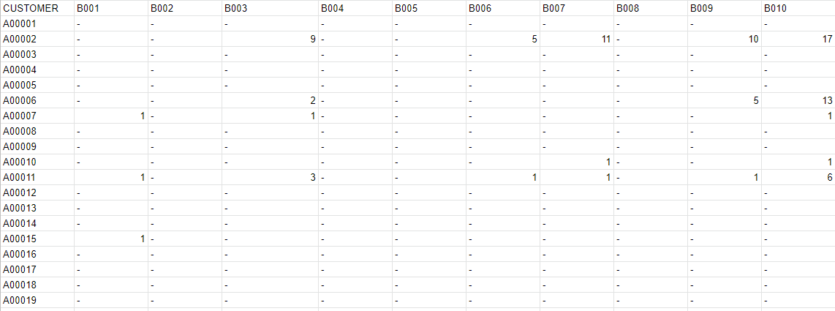

Figure : Masked Data percentage of purchase

Exported data to CSV to read it easily with pandas framework.

## Step 2: Setting Enviroment

* Install python 3.8

https://www.python.org/downloads/

* Install Pandas

To read our data file we will use pandas library.

pip install pandas

* Install sklearn

We are using KMeans Algorithm for calculate distance between customers. We will use sklearn library for that.

pip install sklearn

* Install matplotlib

For visualization our result, we will use matplotlib library.

pip install matplotlib

## Step 3: Python Code

Data Load and Setting Features of the data

#data load

train = pd.read_csv("PROJECT_DATA.csv",";")

#data read

full_feature_list=['B001','B002','B003','B004','B005','B006','B007','B008','B009','B010','B011','B012','B013','B014','B015','B016','B017','B018','B019','B020','B021','B022','B023','B024','B025','B026','B027','B028','B029','B030','B031','B032','B033','B034','B035','B036','B037','B038','B039','B040','B041','B042','B043','B044','B045','B046','B047','B048','B049','B050','B051','B052','B053','B054','B055','B056','B057','B058','B059','B060','B061','B062','B063','B064','B065','B066','B067','B068','B069','B070','B071','B072','B073','B074','B075','B076','B077','B078','B079','B080','B081','B082','B083','B084','B085','B086','B087','B088','B089','B090','B091','B092','B093','B094','B095','B096','B097','B098','B099','B100','B101','B102','B103','B104','B105','B106','B107','B108','B109','B110','B111','B112','B113','B114','B115','B116','B117','B118','B119','B120','B121','B122','B123','B124','B125','B126','B127','B128','B129','B130','B131','B132','B133','B134','B135','B136','B137','B138','B139','B140','B141','B142','B143','B144','B145','B146','B147','B148','B149','B150','B151','B152','B153','B154','B155','B156','B157','B158','B159','B160','B161','B162','B163','B164','B165','B166','B167','B168','B169','B170','B171','B172','B173','B174','B175','B176','B177','B178','B179','B180','B181','B182','B183','B184','B185','B186','B187','B188','B189','B190','B191','B192','B193','B194','B195','B196','B197','B198','B199','B200','B201','B202','B203','B204','B205','B206','B207','B208','B209','B210','B211','B212','B213','B214','B215','B216','B217','B218','B219','B220','B221','B222','B223','B224','B225','B226','B227','B228','B229','B230','B231','B232','B233','B234','B235','B236','B237','B238','B239','B240','B241','B242','B243','B244','B245','B246','B247','B248','B249','B250','B251','B252']

selected_feature_list = ['B116', 'B098', 'B094', 'B081', 'B121', 'B126', 'B141', 'B159', 'B185', 'B195', 'B196', 'B201', 'B209', 'B211']

feature_list = full_feature_list

a1 = train['CUSTOMER'].values

D=[]

for feature in feature_list:

    for f in train[feature].values:

        D.append(f)

plt.clf()

D=np.array(D)

customer_size=len(a1)

feature_size=len(D)//customer_size

X = D.reshape((customer_size,feature_size))

We don’t have a fixed cluster size and want to determine it. So we will run our KMeans algorithm for cluster size 2 to our defined cluster range and we will store it’s silhouette score to our array. We will store the results in our filesystem.

def write_file(fn, str):

    with open(now_str+'/'+fn, "w") as text_file:

        print(str, file=text_file)

silhouetteX= []

silhouetteY= []

file_name='_featuresize'+str(feature_size)+'_'+str(datetime.datetime.now())

file_name='_featuresize'+str(feature_size)

temp_str=""

#kmeans

x0=datetime.datetime.now()

now_str=x0.strftime("%Y%m%d%H%M%S")

os.mkdir(now_str)

cluster_range=100

for cs in range(cluster_range)-1:

    x=datetime.datetime.now()

    cluster_size=cs+2

    kmeans = KMeans(n_clusters=cluster_size).fit(X)

    score = silhouette_score (X, kmeans.fit_predict(X), metric='euclidean')

    silhouetteX.append(cluster_size)

    silhouetteY.append(score)

    export=""

    for i in range(len(a1)):

        export+=str(a1[i])+";"+str(kmeans.labels_[i])+"\n"

    write_file('export'+file_name+'_'+str(cluster_size)+'.csv', export)

    temp_str+="Total time = {} | Calculation time= {} | For n_clusters = {} | silhouette score is {})".format((datetime.datetime.now()-x0),(datetime.datetime.now()-x), cluster_size, score)+'\n'

We are using Principal Component Analysis (PCA) to show result in two-dimensional graph. Code will store graph images on file system.

#PCA

    pca = PCA(n_components=2)

    principalComponents = pca.fit_transform(X)

    principalDf = pd.DataFrame(data = principalComponents

             , columns = ['PC1', 'PC2'])

#    print(principalDf.head())

#    print(principalDf['PC1'].values)

    plt.clf()

    plt.scatter(principalDf['PC1'].values,principalDf['PC2'].values, c=kmeans.labels_, cmap='rainbow')

    plt.savefig(now_str+'/PCA_'+file_name+'_'+str(cluster_size)+'.png')

#/PCA

Logging and store silhouette score graph.

    print("Total time = {} | Calculation time= {} | For n_clusters = {} | silhouette score is {})".format((datetime.datetime.now()-x0),(datetime.datetime.now()-x), cluster_size, score))

plt.clf()

#plt.scatter(silhouetteX, silhouetteY)

plt.plot(silhouetteX, silhouetteY, linewidth=3)

#plt.show()

plt.savefig(now_str+'/silhouette_'+file_name+'_'+str(cluster_range)+'.png')

write_file('log_'+file_name+'.txt', temp_str)

## Step 4: Run the code

It takes total 9 minutes 24 seconds. It takes longer when the cluster size increases.

For example for cluster size 4 it takes around 1 seconds but it takes around 9 seconds for 100 clusters. Interesting result is maximum time spent (10 sec.) while calculating for cluster size 88.

Total time = 0:00:01.049263 | Calculation time= 0:00:01.047054 | For n_clusters = 2 | silhouette score is 0.8226367402696589)

……………………

……………………

Total time = 0:00:13.667354 | Calculation time= 0:00:02.012510 | For n_clusters = 10 | silhouette score is 0.7822199519312913)

……………………

……………………

Total time = 0:04:34.803758 | Calculation time= 0:00:06.729990 | For n_clusters = 67 | silhouette score is 0.693718271801207)

……………………

……………………

Total time = 0:07:18.179784 | Calculation time= 0:00:09.550510 | For n_clusters = 87 | silhouette score is 0.684521772689901)

Total time = 0:07:28.398423 | Calculation time= 0:00:10.211659 | For n_clusters = 88 | silhouette score is 0.6406413361498463)

Total time = 0:07:36.780997 | Calculation time= 0:00:08.381577 | For n_clusters = 89 | silhouette score is 0.6144718888012429)

……………………

……………………

Total time = 0:09:15.077126 | Calculation time= 0:00:09.337510 | For n_clusters = 100 | silhouette score is 0.6544412866824009)

Total time = 0:09:24.651828 | Calculation time= 0:00:09.573768 | For n_clusters = 101 | silhouette score is 0.6280913862214829)

## Step 5: Results

**Silhouette score by number of cluster**

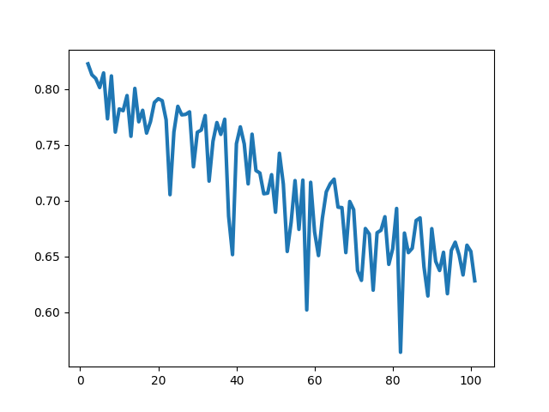

Figure : Silhouette Score by Number of Cluster

Silhouette score is decreasing by cluster size It gives an idea that maximum cluster size must be 20 for our data.

**PCA by number of cluster.**

|  |  |  |
| --- | --- | --- |
| Figure 4: with 2 clusters |  | Figure 5: with 6 clusters |
| Figure 6: with 10 clusters |  | Figure 7: with 14 clusters |
|  |  |  |
|  |  |  |
|  |  |  |

After analyzing the PCA results we can see that large amount of customers are grouped in two main groups. Increasing cluster sizes only create customer groups with few outlier customers.



Figure : Number of Customers by Cluster (3)



Figure : Number of Customers by Cluster (17)



Figure : Number of Customers by Cluster (40)

These outlier customers can be ignored or can be analyze manually to understand why they differ so much from the general distribution. This can be also a new way of marketing strategy. Because if there are some customers with that purchase behavior they there can be more. Also there should be some reason for them; maybe they don’t know the product (leads marketing) or it is not suitable (leads new products) or it’s price (leads new suppliers)

Our example business strategy depends on two different customer segments,

* + Producers; which they are differ from each other by their production area
  + Distributors; which purchase all kind of products to sell smaller producers

Which is covers current results, Distributors are few in number but their turnover is high, Producers are numerous and their turnover varies according to their size.

While distributors differ only according to their size, the sub-segments of the manufacturers vary according to the types of furniture they make. For example, those who produce Kitchen Furniture may be our first sub-segment, while those who produce wardrobes may be the second, but those who produce both may be our third segment.

**What could be the benefit of this study?**

The potential in relatively small customers can be recognized and a sales strategy applied to similar customers can be applied to them. This will potentially increase amount of sales made to that.

By investigating product differences within the group, customers who do not buy common product groups can be offered sales opportunities by offering these product groups.

**What can be done after;**

* We can be another sub clustering customers in their main cluster. This can make small details among customers more distinct
* We can also work on product groups. Removing the most common product group from the data can make the difference between customers distinct.

# APPENDIX

The codes and result files are stored in public GitHub repository.

<https://github.com/omerfkara/Capstone>

# REFERENCES

[1] <https://towardsdatascience.com/clustering-algorithms-for-customer-segmentation-af637c6830ac>

[2] <https://towardsdatascience.com/customer-segmentation-using-k-means-clustering-d33964f238c3>

[3] <https://www.optimove.com/resources/learning-center/customer-segmentation-via-cluster-analysis#:~:text=The%20clusters%20that%20result%20assist,their%20wants%2C%20needs%20and%20preferences.&text=Rather%2C%20the%20data%20itself%20reveals,within%20the%20population%20of%20customers>.

[4] <https://towardsdatascience.com/k-means-clustering-algorithm-applications-evaluation-methods-and-drawbacks-aa03e644b48a>

[5] <https://medium.com/@jyotiyadav99111/selecting-optimal-number-of-clusters-in-kmeans-algorithm-silhouette-score-c0d9ebb11308>

[6] <https://www.dezyre.com/data-science-in-python-tutorial/principal-component-analysis-tutorial>